**1. Create  Client server based Application  using Node.js to display message**

**Answer:**

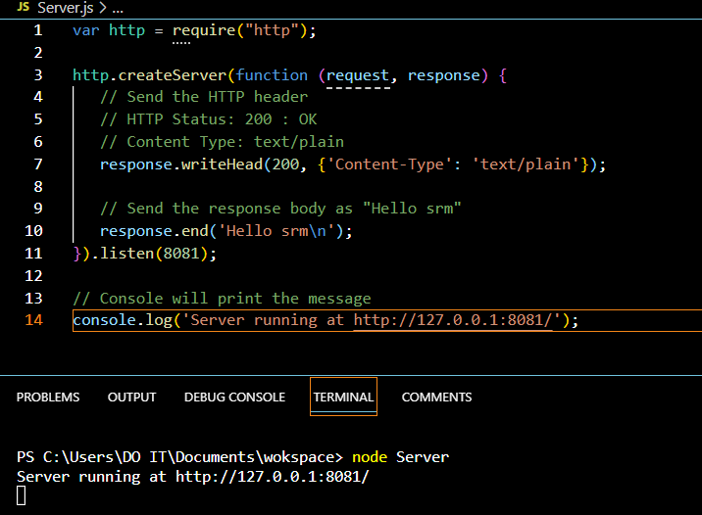

**Output:**

